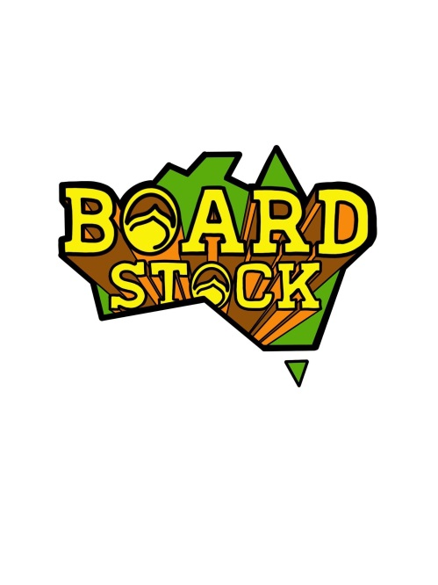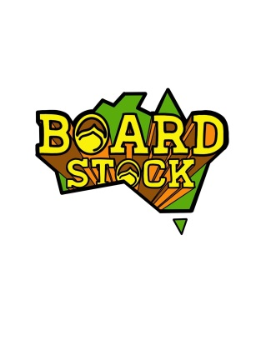

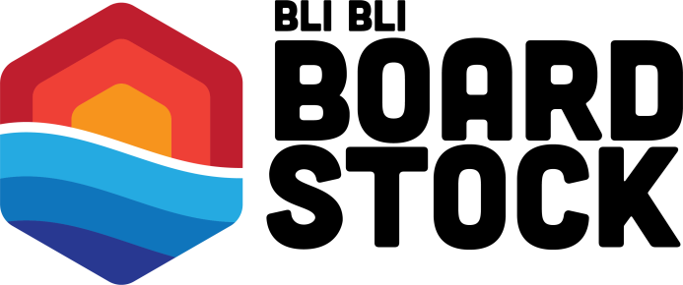

**APRIL 2nd & 3rd**

**The Events**

In 2022 there will be 2 contest events only at Bli Bli Watersports.

The **King of the Kickers Event** will be staged on the front lake from 2pm Saturday 2022 using dual kickers. Both kickers will be positioned on the right side of the cable, one before the motor tower and one after the motor tower. Divisions will include Under 10 boys and Girls (reduced speed), Under 13 Boys and Girls, Under 17 Boys and Girls, Amateur Men and Women, and Pro Men and Women.

Presentations will immediately follow the completion of the event with a sausage sizzle/BBQ and music on the deck until 8pm

The **Features Only Event** will be staged on the front lake from 8am Sunday 2022 using all the rails and kickers, as well as some new “lines” for the pro’s…Divisions will include Under 10 Boys and Girls (reduced speed), Under 13 Boys and Girls, Under 17 Boys and Girls, Amateur Men and Women, Wakeskate pro and Amateur, plus Pro Men and Women.

Presentations will immediately follow the completion of the event

Rules and Judging guidelines are all available in separate documents

**The Proposed Schedule**

**APRIL 2nd & 3rd**

**Saturday 12pm** – Practice on the Kickers Course

**Saturday 2pm** – King of the Kickers Contest

**Saturday 6pm** – King of the Kickers Presentation

**Saturday 6pm to 8pm** – Sausage sizzle/BBQ with Music

***………The bar will be open until 8pm……***

***.* Sunday 8am** – Features Only Contest

**Saturday 3pm** – Features Only Presentation

**Saturday 4pm** – End of Contest

***……Cable opens to the public for final ride……***

**All times are SUBJECT TO CHANGE!!! (at the discretion of the event organisers)**

*It is the riders responsibility to know when and where their events are taking place*

*Updates will be posted on the “Boardstock” social media Instagram pages*

